✴

# Document an existing experience

**TIP**

As you add steps to the experience, move each these “Five Es” the left or right depending on the scenario you are documenting.

Narrow your focus to a specific scenario or process within an existing product or service. In the **Steps** row, document the step-by-step process someone typically experiences, then add detail to each of the other rows.

Customer experience journey map

Use this framework to better understand customer needs, motivations, and obstacles by illustrating a key scenario or process from start to finish.

When possible, use this map to document and summarize interviews and observations with real people rather than relying on your hunches or assumptions.

Created in partnership with

**Steps**

**SCENARIO**

**Browsing, booking, attending, and rating a local city tour**

What does the person (or group) typically experience?

## Interactions

What interactions do they have at each step along the way?

**People:** Who do they see or talk to?

**Places:** Where are they?

**Things:** What digital touchpoints or physical objects would they use?

# Entice

How does someone initially become aware of this process?

Customer care support through communications

Online and telecommunications methods are available for customers

Chatbots are available for the help of customers

# Enter

What do people experience as they begin the process?

**Creating an account**

**User friendly interface**

**Simple GUI design**

Easy login and surfing through products

Customer experience the friendly interface on using this.

User interface with all services related to inventory

Access the various modules from one place dashboard

Automated service for placing the order

# Engage

In the core moments in the process, what happens?

**Unnecessary product details can be limited**

**Information regarding the warehouse and rank according to stars**

**Details of the product sales**

**Displaying the most purchased product and seasonal production list**

**Give employees the right inventory tools for the job.**

Chatbot interaction is available for the customers

Adding the inventory details and products

Placing the order widgets to place order

# Exit

What do people typically experience

as the process finishes?

**Alerting the shortage of products**

**After purchasing billing can be done through online via multiple gateways**

Email and notification for the customers

Providing the tracking details of the goods

# Extend

What happens after the experience is over?

**24 * 7**

**Customer support**

**Getting the feedback after purchases.**

Sharing in social media about their experience with the product

**Provding credit points**

**Connect with social media**

**User have to create an account for utilize our product and for future use**

**Enter the necessary details and information for the customer**

**Tracking the products and when they be available**

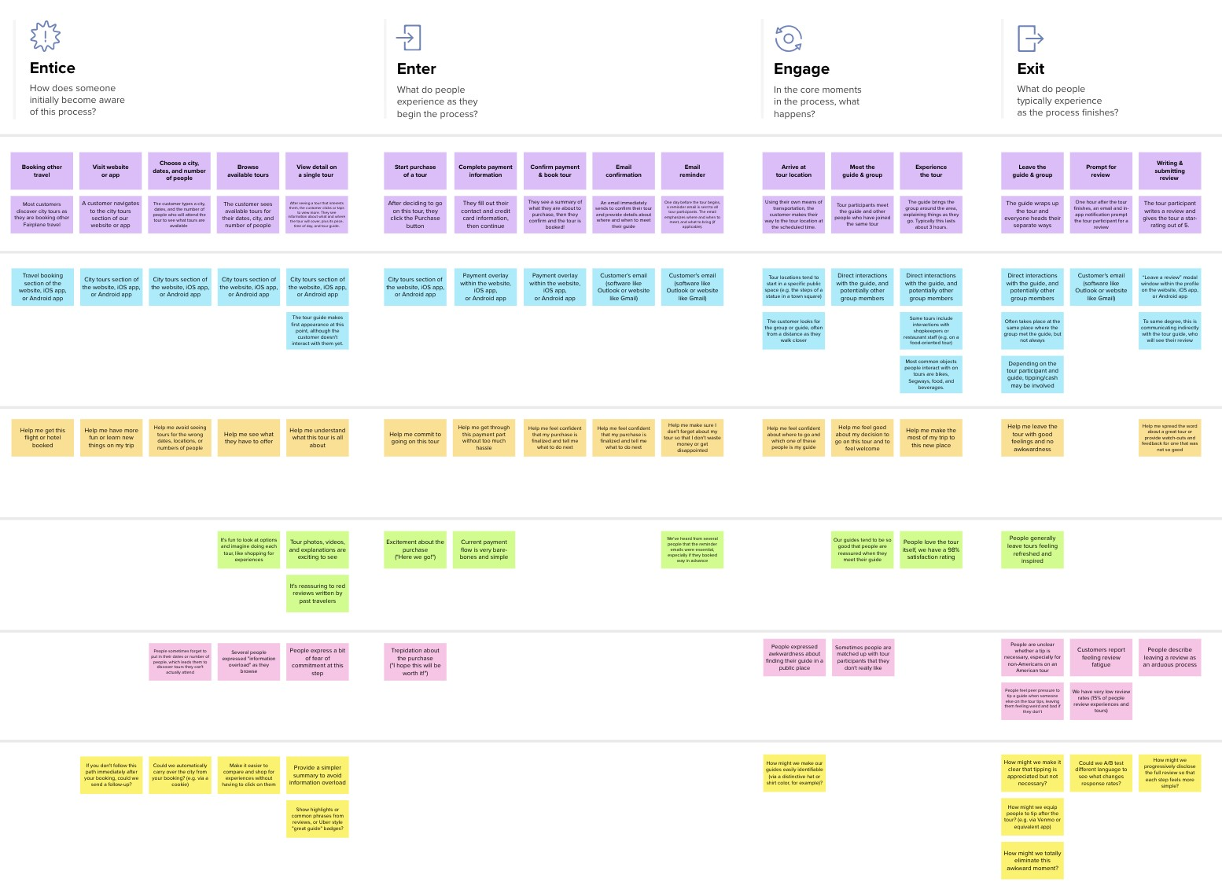

**Template**

**Goals & motivations**

Tracking the goods and location of inventory must be improved

stock levels and stock's location in warehouses.

Hekos ti tracks the flow of products from supplier through the production process to the customer.

Time management should be improved

Notification service of shortage of goods will increase the productivity in availability of stocks

Unwanted information were hidden

Avoid flooding of information

Cost efficient management

Consistent tracking of data with centralized cloud based technique

Ensuring sufficient supply of goods

Tracking of inventory stocks availability must be made easier

Ease of placing the order

Customer satisfaction must be confirmed

Avoid of shortage of stocks

Account creation must be made simple

Displaying the stock details in dashboard

Displaying details of the products to be arrived

At each step, what is a person’s primary goal or motivation? (“Help me...” or “Help me avoid...”)

## Positive moments

Extending the features provided in the application

Improving the performance with the feedback

What steps does a typical person find enjoyable, productive, fun, motivating, delightful, or exciting?

Increase the profit

User get satisfy and happy with the performance of the applicatoin

Automated reordering

Shortage of stocks can be avoided

optimize storage space and inventory flow.

Registration/Signup can be done easily

Products description with images enhance the users

Savings can be improved

Greater Insights

Notificaions when limitation of stock is reached

## Negative moments

Expanding Product Portfolios

Some modues may take time to load

Slowness in retrieving data

What steps does a typical person find frustrating, confusing, angering, costly, or time-consuming?

Inconsistent tracking of the stocks

Frustration in using the product

Problem in the servers

Some inventory management techniques and tactics can be difficult to comprehend.

Poor planning in the maintenance of the user interface

Mananging warehouse space

Scaling low-tech standard operating procedures is challenging.

## Areas of opportunity

Human error should be reduced

Stock auditing will be made easier

Transparent performance

How might we make each step better? What ideas do we have? What have others suggested?

Frequent updates of stock detials

Processes for routinely auditing stock, such as day-to- day cycle counting

Globalised supply chains

Consider whether the top 20% of your inventory, which accounts for 80% of customer demand, is still available.

Increasing Competition i

keep backup supplies on hand to counteract supply chain interruptions

[**Share template feedback**](https://muralco.typeform.com/to/CiqaHVat?typeform-source=app.mural.co)

**Need some inspiration?**

|  |  |  |  |
| --- | --- | --- | --- |
|  |  |  |  |
|  |  |  |  |

|  |  |  |  |  |  |  |  |  |
| --- | --- | --- | --- | --- | --- | --- | --- | --- |
|  |  |  |  |  |  |  |  |  |
|  |  |  |  | |  |  |  |  |

|  |  |  |  |  |  |  |  |  |
| --- | --- | --- | --- | --- | --- | --- | --- | --- |
|  |  |  |  |  |  |  |  |  |
|  |  |  |  | |  |  |  |  |

See a finished version of this template to kickstart your work.

[**Open example**](https://app.mural.co/template/f59f644b-b4b4-47b5-9ed6-3a8c71ceb612/896b31fe-5597-40ef-9b06-3811a1a45ace)